(Approx. 1,765 words)

Corel Paint It
By Lynn Page, Newsletter Editor/Webmaster, Crystal River Users Group, FL
March 2011 issue, CRUG newsletter
www.crug.com
editor@crug.com

Overview
Corel’s latest photo painting application, Paint It, is based on Painter, their professional natural media painting application. Painter provides a very wide range of brushes and textures for the artist. It is the standard for professional art programs and as such requires a high degree of skill and talent to use effectively. Corel Painter Essentials is a step down in difficulty and versatility so is easier to use but still requires some time to learn. Corel's Paint It is their newest and easiest painting program.

Paint It has a selection of brushes, such as an airbrush, pen, pencil, sponge, and smudge tool, to make photos into a painting, charcoal sketch or pencil drawing. The primary purpose of Paint It is the automated photo painter but the brushes let you add your own special effects to the painting. I tried out a lot of the brushes on the finished photo paintings and used a couple of the brush tools on a photo prior to photo painting. For ease of use and simplicity the tools and interface are limited.
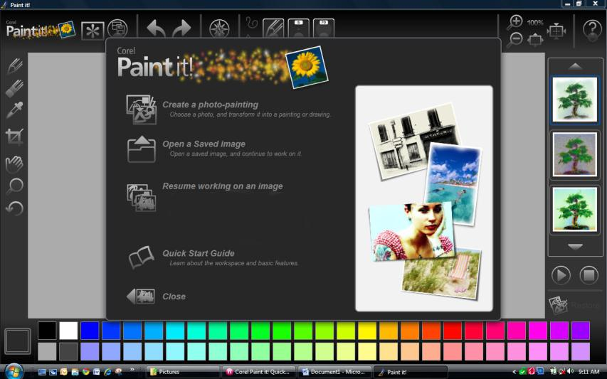

Paint It opens with a welcome screen in front of the workspace. This allows you to easily select a photo for photo painting, resume working on an already opened photo or open the Quick Start Guide.

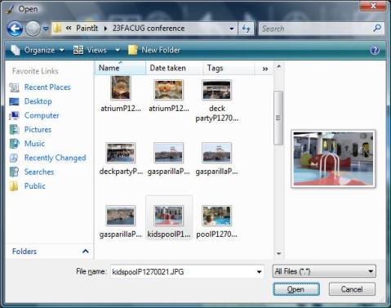

Clicking “Create a photo-painting” or “Open a Saved Image” opens a dialog box to browse to and open the photo to be painted. As an example I chose a picture I took of the children’s pool at the FACUG Technology Conference/Cruise.

Workspace
The Paint It workspace is very clean and simple. The Toolbar across the top over the working image has obvious access to undo and redo commands, save, brushes and brush controls, view option, and program help. Less obvious are the Get Started link (asterisk like button) and the controls for transforming the open image (star like button). I think the transform image controls are important enough that I would like to see a grouping of smaller icons representing them on the toolbar. However mousing over any of the buttons on the Toolbar or in the Toolbox gives a tooltip so all tools and commands are still easy to find.
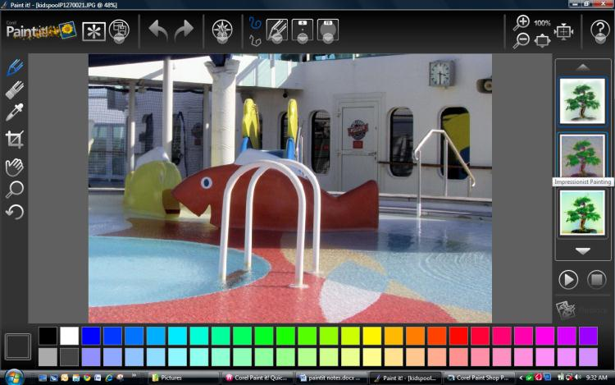
The Toolbox down the left edge of the workspace contains icons for important tools. Remember that the brush icon selects the brush as it has been defined in the brush drop down menu on the toolbar. The color palette is located below the working image. The Photo Painting pane runs down the right edge of the workspace.

The heart of Paint It is the photo painter. You choose from among the 10 styles, such as Oil Painting, Impressionist Painting, Detailed Watercolor or Pen & Ink Drawing that are displayed in the Photo Painting panel down the right side of the workspace. After selecting a painting style click the Start Photo Painting button, and watch the program create the painting in the selected style. The automatic photo painting is based on the colors and composition of the photograph. Let the photo painting run to completion or stop it at any time by clicking the Stop Photo Painting button. When a painting is complete some of the photographic detail can be added back with the Restore detail brush, located in the photo painting pane below the start and stop photo painting buttons. This brush is especially useful when painting photographs of people. Select the Restore detail brush and the brush area on the Toolbar becomes visible again. The brush tools are not available during photo painting or afterwards until the restore detail brush or a brush tool in the Toolbox is selected. Set the brush opacity and size and then brush over areas where you want the detail brought back.

After photo painting Paint It allows you to add finishing touches to the project. Add a signature, embellishments or smudge or soften the image with the brushes. A pressure sensitive tablet provides better use of the brushes but a mouse or laptop touchpad can also be used.

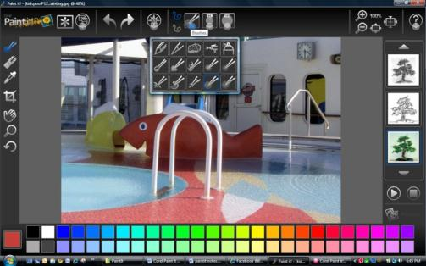
Brushes
Paint It contains 15 brushes plus the restore detail brush, many with control over color, size and opacity. The brushes can be used on the finished photo painting or the original photo. The specialty Fire, Fairy Dust, Leaf, and Pattern brushes have limited or no control over color. The other brushes either work with the color in the underlying image or with a user selected color.

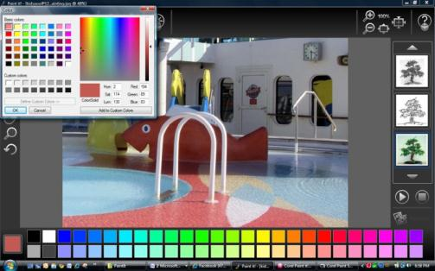
Color Palette
The Color Palette on the bottom of Paint’s workspace offers a selection of colors to be used with the color controlled brushes. I like to use the eyedropper tool, from the Toolbox on the left, to pick a color from the photo. Once a color is selected, it can be further refined with the Color dialog box. Click the color swatch of the selected color to open the Color dialog box. The dialog box lets you choose a basic color or any color in the color spectrum associated with that color.

The Color Palette doesn’t change so personally selected colors aren’t available after you have selected another color. This is not too inconvenient as it is simple to use the eyedropper to reselect a color. So if it is important for you to use exactly the same color it is better to use one from the palette.

Printing
Paint It's print command is located in the Image destination drop down menu that looks like a save button on the Toolbar. It opens the Windows print dialog box. So I would print the finished image as any other saved photograph.

Conclusion
I found Corel Paint It is a fun, easy-to-use program. It is ideal for novices who enjoy working with their pictures and want simple way to convert a photo into a basic painting or drawing. For more control to create art that is finely tuned Corel Painter Essentials is still my choice. And I am looking forward to working with Corel Painter which I won at the FACUG conference.

Photo Paintings
As previously noted my first Paint It painting was of the children’s pool on our cruise. I selected it because it is a simple picture with bright colors.
With the image to paint open, look at and select a painting style from the thumbnails on the photo painting pane. I missed being able to see the thumbnail of the selected image as on Painter Essentials but the thumbnail still gives you an idea of how the painting will look. Mousing over the thumbnail displays the painting style. I choose impressionist. Click the thumbnail to select it and click the start photo painting button to start automatic photo painting.

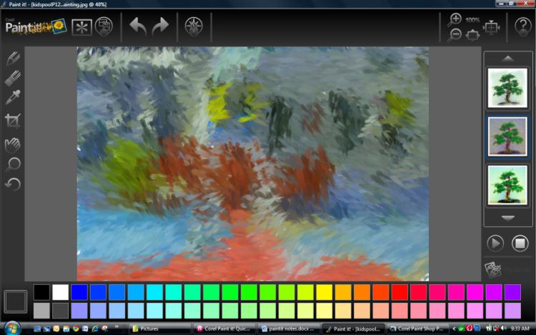
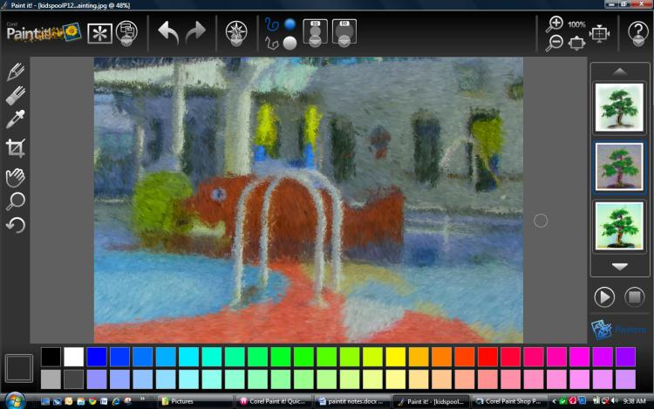
As Paint It is painting the image watch the brush strokes. The paint colors and brush stroke directions follow the photo colors and lines as they would when actually painting. The brush strokes get smaller and shorter as painting finishes. You can click the stop photo painting button at any time in the painting process or let Paint It run to completion.
This is how the impressionist painting looks at an intermediate point in the painting process and as the finished painting.

I used the restore detail brush to bring out the eye. To save the finished painting click the Image Destination button in the toolbar and select save image as. I use save as to have the most control but there is also a save button.

Adding Embellishments
For embellishments I selected the furry brush and with the eye dropper tool set the color to one from the fish and painted in an extended tail.
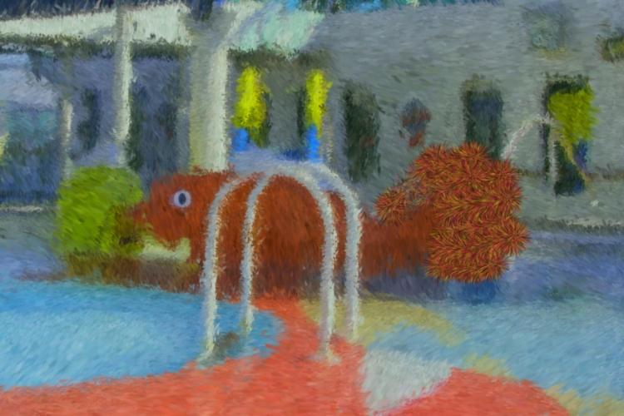

Other Photo Painting Styles
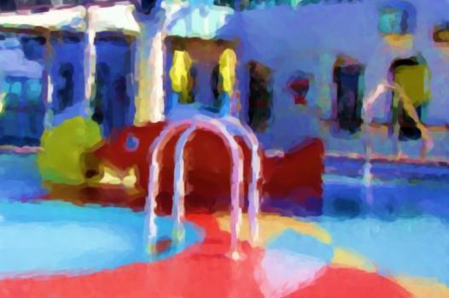 | 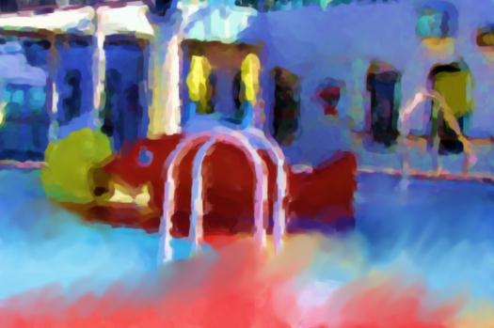
Modern Painting | Modern Painting with Smudge brush to blend the colors in the pool.

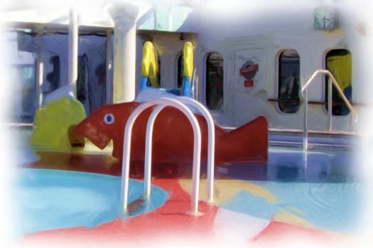 | 
Oil Painting | Oil Painting with Pattern pen on walls and columns of the oil painting, the Fire brush in water, the Fairy dust to add random color sparkles and the Leaf brush to paint in green leaves for the embellishments.
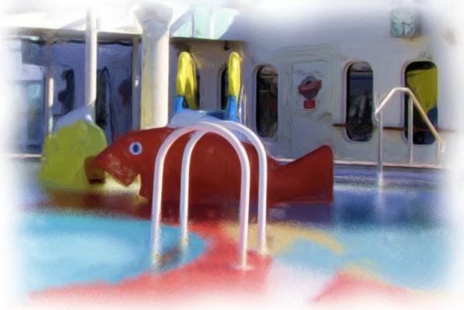
Oil painting with the Dissolve brush giving a pebbly look to the water.
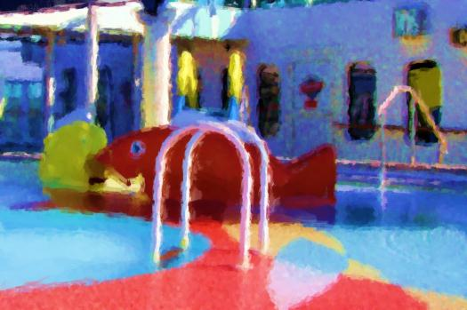 | 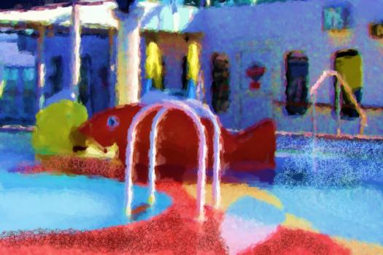
Detailed Watercolor Painting | Detailed Watercolor Painting embellished with the Sponge brush using colors selected from the painting.
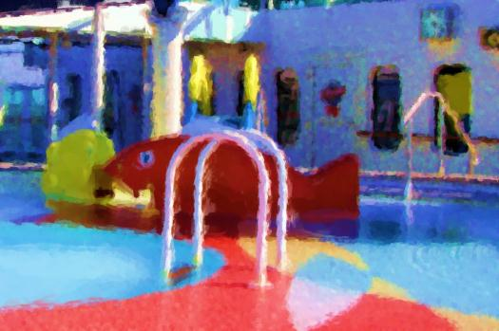 | 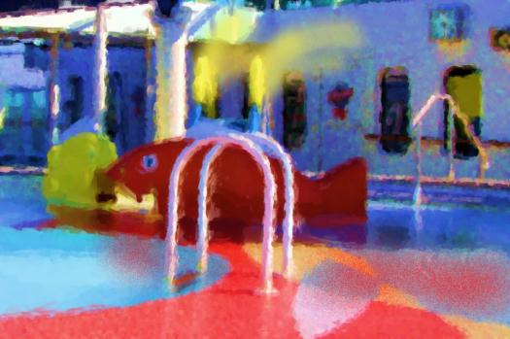
Illustration | Illustration with red spray painting in the water and airbrush of the yellow on the slide.
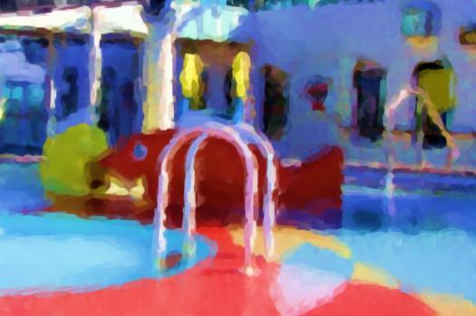
Modern Painting | Modern painting with colors in the pool blended with the Smudge brush.

The automatic photo painting is based on the colors and composition of the photograph. With all of these painting styles the paint colors and brush stroke directions follow the photo colors and lines as they would when actually painting. The brush strokes get smaller and shorter as painting finishes. Pencil drawings are different in the direction of the strokes. The pencil strokes are all parallel strokes. The Watercolor Sketch is a combination of painting strokes like the watercolor style embellished with pen or pencil strokes.
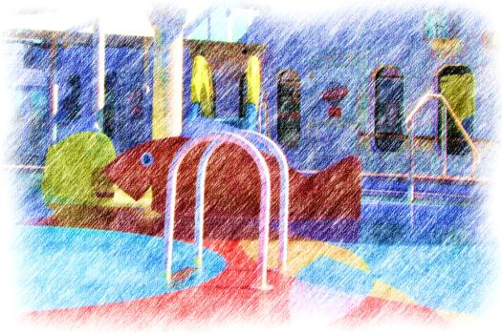 | 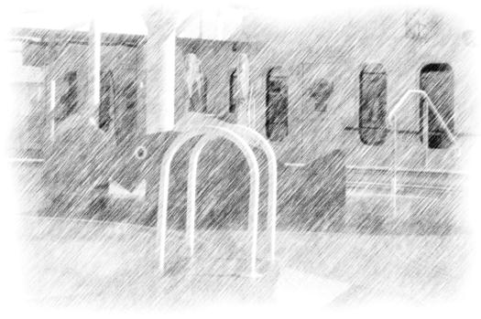
Colored Pencil Drawing | Pencil Drawing

Paint It also has two sketching styles pen and ink and watercolor sketching.
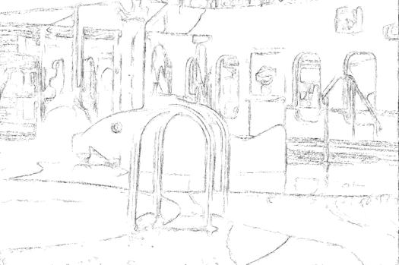 | 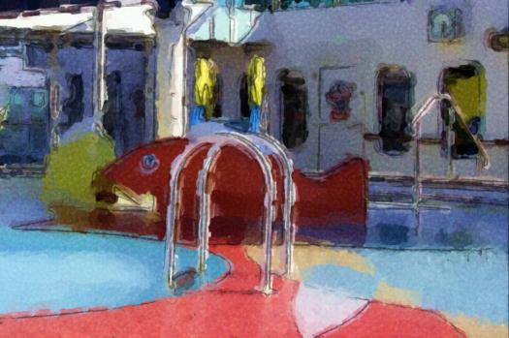
Pen and Ink Sketch | Watercolor Sketch

Before doing another painting I used Corel Paint Shop Photo Pro X3 to remove the hand rail on the original photo. Then I used the Oil painting style in Paint It. After the photo painting I used the Distortion brush to drastically thin down the fish and elongate the tail and dorsal fin. Place brush in area to move and drag it to paint into another area stretching or pushing the color from the original area. Finally I used the wave brush along the water.
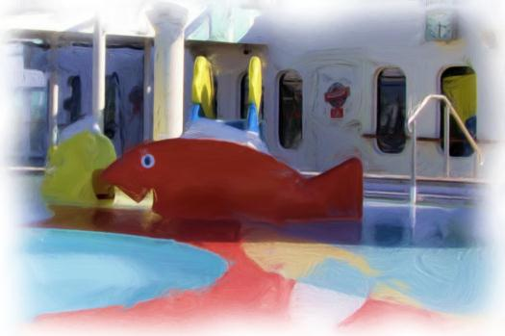 | 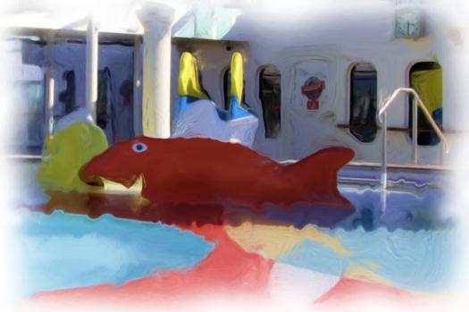
Oil Painting | Oil Painting with Distortion brush to blend the colors in the pool.

The brushes can be used on the original photograph as well as on the finished photo painting. So here I used the Distortion brush and Wave brush before running the Oil and Impressionist photo painting styles.
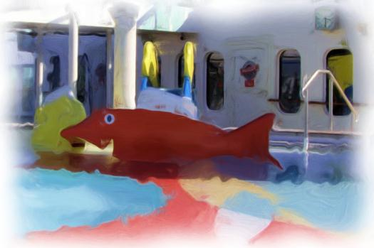 | 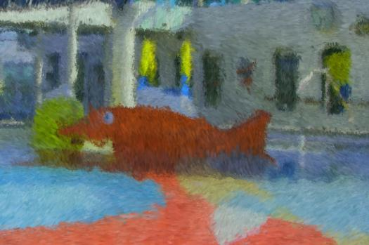
Oil Painting | Impressionist Painting

I chose the photograph of the pool because of its simplicity so that the painting styles would be very evident. To show Paint It with a more complicated photograph I chose a sample of a stream with cascades and varied foliage.
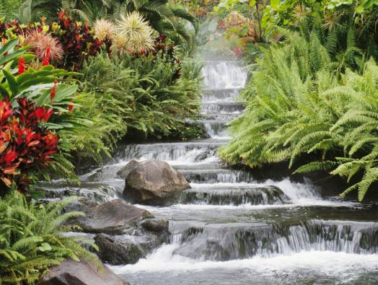 | 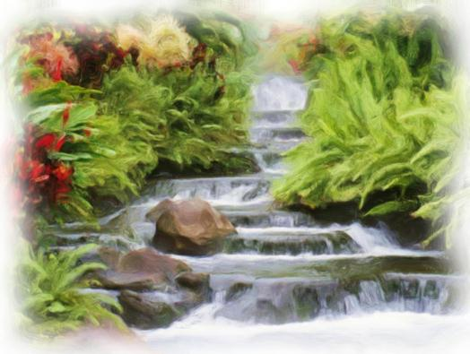
Original | Oil Painting
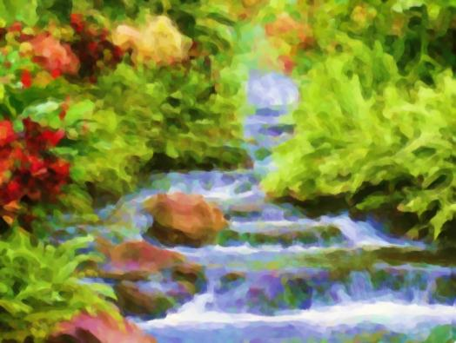 | 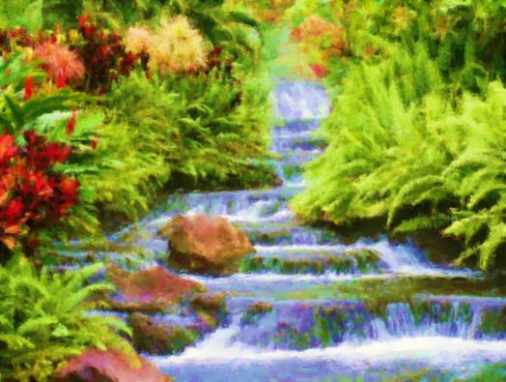
Modern Painting | Illustration
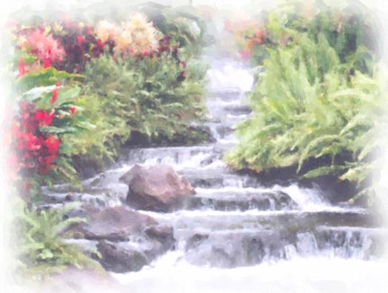 | 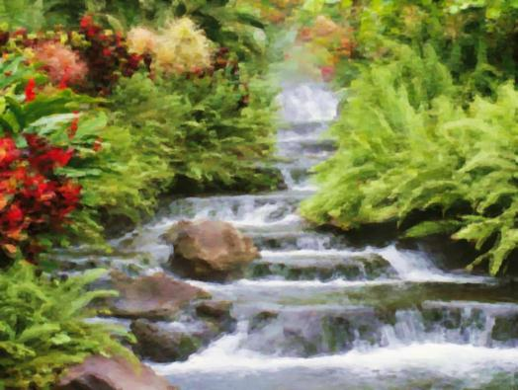
Detailed Watercolor | Pastel

Paint It lists for about $40 but I found it available online for under $20. For such a reasonable price it is incredibly versatile and amazingly easy to use photo painting application. This makes it an ideal way to step into something new with digital photos. It is even suitable for children to get a taste of expressing their artistic likes and dislikes.

